Prisliste - Art by Mano

The greenlandic mask of motherhood, (big) 4.400

Tsakker (small) – East greenlandic womens knife 1.600

ULO - West greenlandic womens knife 3.300
Tsakker – East greenlandic womens knife 3.300

Mother & Child 3.300

Creation of life, Introvert 3.300
Creation of life, Extrovert 3.300 2 for 6.000

Creation of life, Internal 3.300
Creation of life, External 3.300 2 for 6.000

Creation of life, 3.300
Creation of life, 3.300 2 for 6.000

Ice Cave 2.200

Divers perspective 2.200
Drone perspective 2.200 2 for 6.000

Monetary Icon I 650
Monetary Icon II 650 2 for 1.200

El Toro 650

Grenlandic Glacier 4.800

Facebook.com/ArtbyMano

AUKTION

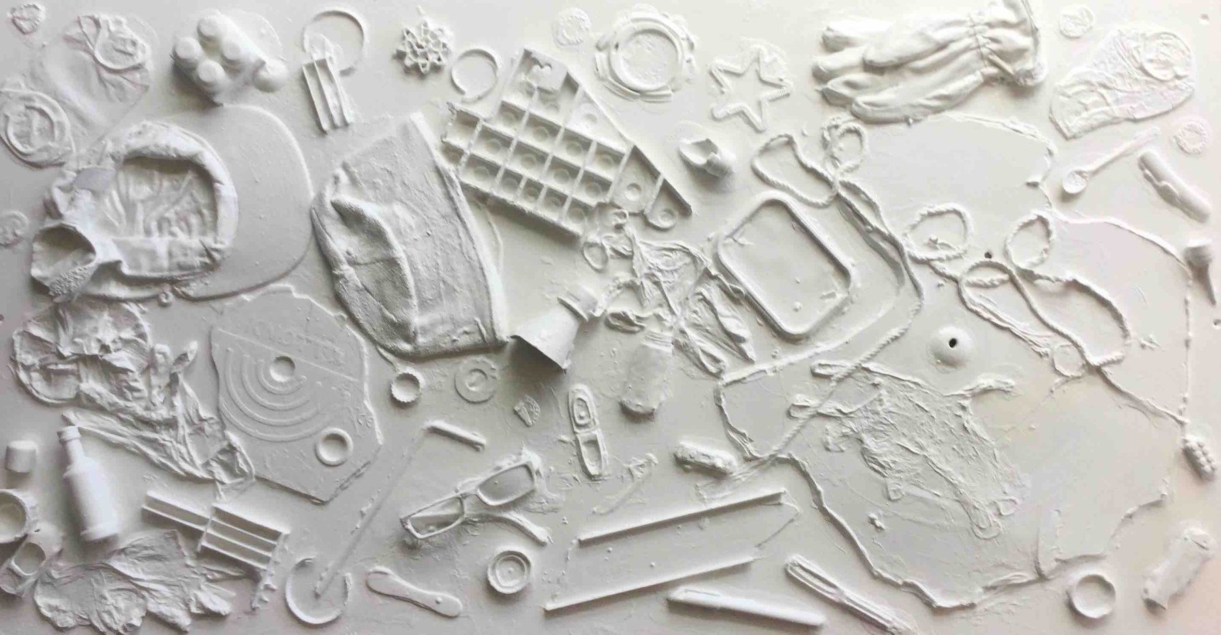
»Pure Garbage« , DKK 2.500 +

Sælges til fordel for børneorganisationen Mio for højeste bud over 2.500 inden kl. 17.30 torsdag den 6 december 2018.

Skriv dit bud og telefonnummer på sedlen ved værket inden 17.30

»Projekt Rent Skrald«
-handler ikke om at bebrejde nogen, men måske ville det være lettere, hvis vi ikke smider så meget affald i naturen - for vores børns fremtid !!!
For så vidt angår børnenes fremtid, sælges dette rene skrald til fordel for MIO - en organisation, der arbejder for børns rettigheder og desuden kører et børneråd - for det højeste bud inden torsdag den 6. december kl. 17.30. ved åbningen af udstillingen i Grønlands Banken.

---

»Pure Garbage« , DKK 2.500 +
Sold for the benefit of the children's organization Mio for the highest bid over 2,500 by noon. 17.30 Thursday, 6 December 2018.

Write your bid and phone number on the paper at the artwork before 17.30

»The Pure Garbage Project«
- is not about blaming anyone, but maybe it would be easier if we did not throw so much waste in nature - for the future of our children!!!
So for the sake of the children's future, this pure garbage is sold in favor of MIO – an organization working for Children's Rights and also running a Children's Council - for the highest bid before Thursday 6 December at. 5.30 pm. at the opening of the exhibition in the Bank of Greenland.

Facebook.com/ArtbyMano

AUKTION

BUD I DKK Telefon nummer Navn (frivilligt)

